Lab 11 (50 points)

Kyle AuBuchon

Q1 (15 points)

1. Write assembly code to display the following:

A program to add two numbers

Value of the first Integer Number is 25

Memory location of the first Integer Number is

Value of the second Integer Number is 13

Memory location of the second Integer Number is

And display again all information in one line

1. Run the code and take a screen shot of the output

3- In one file, include your code and the screen shot of the run

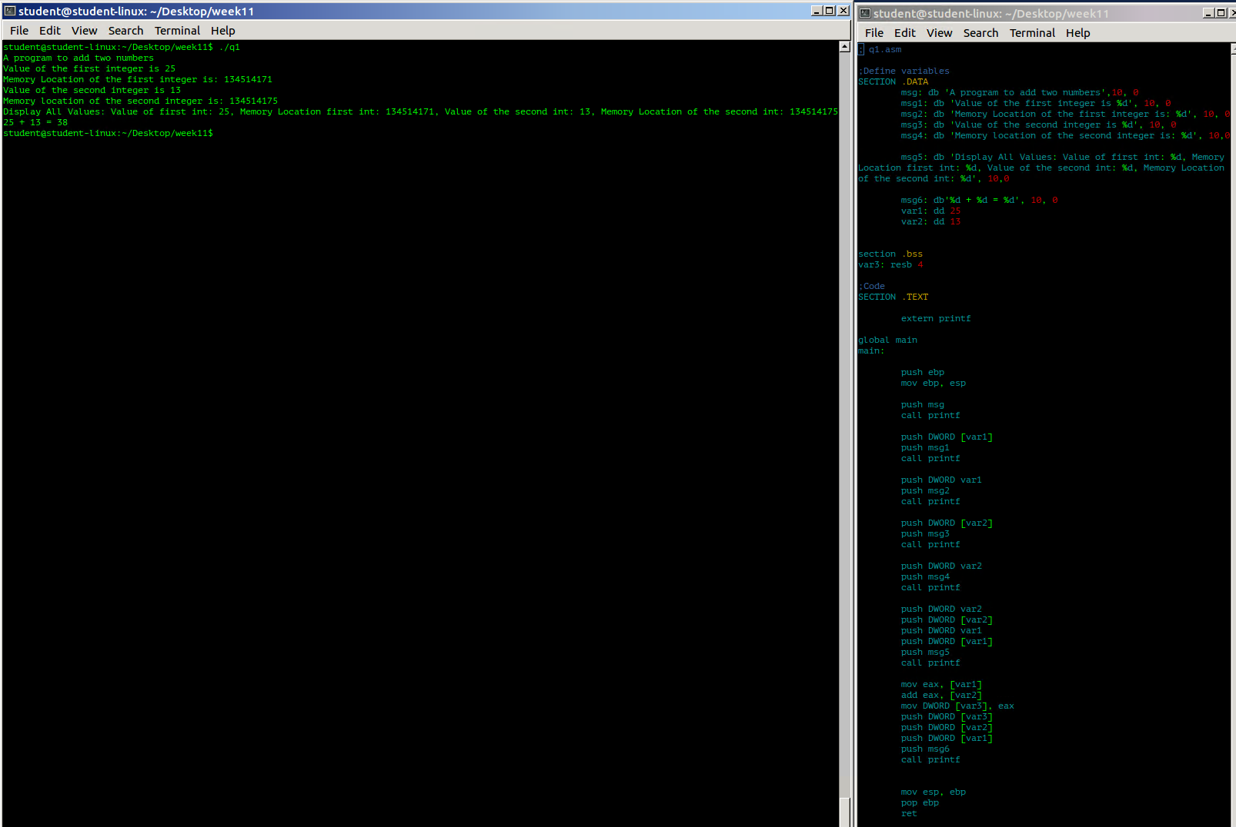

Q2 (15 points)

1- Create a file “file1.txt” that has your name

2- Write assembly program to copy “file1.txt” to a new file “file.txt”

3- Run the code and take a screen shot of the output

4- In one file, include your code and the screen shot of the run

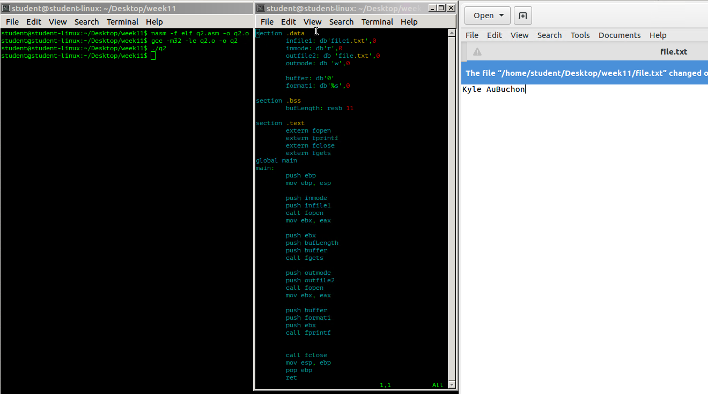

Q3 (20 points)

1. Write assembly code using printf and scanf to display the following:

What is your first name?

What is your age?

When will you graduate?

Hi “display first name”, when you graduate, your age will be (display the new age)

2- Run the code and take a screen shot of the output

3- In one file, include your code and the screen shot of the run

